Ninth report on the costs of the Australian Government’s Run-Off Cover Scheme for medical indemnity insurers
2012-13 financial year

© Commonwealth of Australia 2015
ISBN 978-1-925220-37-7
This publication is available for your use under a Creative Commons BY Attribution 3.0 Australia licence, with the exception of the Commonwealth Coat of Arms, the Treasury logo, photographs, images, signatures and where otherwise stated The full licence terms are available from http://creativecommons.org/licenses/by/3.0/au/legalcode.
Use of Treasury material under a Creative Commons BY Attribution 3.0 Australia licence requires you to attribute the work (but not in any way that suggests that the Treasury endorses you or your use of the work).
Treasury material used ‘as supplied’.
Provided you have not modified or transformed Treasury material in any way including, for example, by changing the Treasury text; calculating percentage changes; graphing or charting data; or deriving new statistics from published Treasury statistics — then Treasury prefers the following attribution:
Source: The Australian Government the Treasury.
Derivative material
If you have modified or transformed Treasury material, or derived new material from those of the Treasury in any way, then Treasury prefers the following attribution:
Based on The Australian Government the Treasury data.
Use of the Coat of Arms
The terms under which the Coat of Arms can be used are set out on the It’s an Honour website (see www.itsanhonour.gov.au).
Other uses
Inquiries regarding this licence and any other use of this document are welcome at:
Manager
Communications
The Treasury
Langton Crescent
Parkes ACT 2600
Email: medialiaison@treasury.gov.au
Table of contents
1. Introduction 1
2. Background 1
2.1 Medical indemnity insurance 1
2.2 Brief history of private medical indemnity insurance in Australia — the lead-up to the Run-Off Cover Scheme 3
2.3 What is the Run-Off Cover Scheme? 4
3. Data 6
3.1 Data collection 6
3.2 Data verification 6
3.3 Eligible practitioners 7
3.4 Claims eligible for Run-Off Cover indemnity payments 9
3.5 Run-Off Cover indemnity payments 10
3.6 Run-Off Cover support payments 11
4. Financial management of the Run-Off Cover Scheme 14
4.1 Future liabilities of the Run-Off Cover Scheme 14
4.2 Notional Account 17
4.3 Actuarial management 20
Appendix 1: Run-Off Cover support payments 21
Appendix 2: Eligible practitioners and Run-Off Cover Scheme contracts 22
Appendix 3: Run-Off Cover Scheme claims 24
Appendix 4: Methodology, assumptions and uncertainty 25
Appendix 5: High cost claims 37

Introduction
  - This report has been prepared to comply with certain requirements of the Medical Indemnity Act 2002 (Medical Indemnity Act). Section 34ZW of the Medical Indemnity Act provides for a report on aspects of the Run-Off Cover Scheme (the Scheme) to be tabled each year in Parliament. The report is required to contain a statement of the:
- number of persons eligible for membership of the Scheme;
- total Run-Off Cover indemnity payments (ROC indemnity payments) paid by the Commonwealth during the financial year, including claims handling and administration expenses;
- total Run-Off Cover support payments (ROC support payments) paid to the Commonwealth during the financial year; and
- projected liabilities of the Scheme in future financial years.
  - This is the ninth report that has been prepared under section 34ZW of the Medical Indemnity Act. It relates to financial year 2012-13. The eighth report was tabled in Parliament on 5 March 2014.

Background

Medical indemnity insurance

    - Medical indemnity insurance is a form of professional indemnity insurance. It covers practitioners for their professional negligence.
    - Doctors who undertake private medical practice in Australia generally purchase medical indemnity insurance from private sector underwriters. This report considers the five private sector underwriters operating in Australia during 2012-13. Figure 1 below illustrates the market shares of the five private underwriters calculated on the basis of premium data provided by them.
    - The five private underwriters operating in Australia during 2012-13 were Avant Mutual Group Limited (Avant), MIPS Insurance (MIPSi), MDA National Insurance (MDANI), Medical Insurance Group Australia (MIGA), and QBE Insurance (Australia) Ltd (QBE).
Figure 1: Market share of medical indemnity insurers

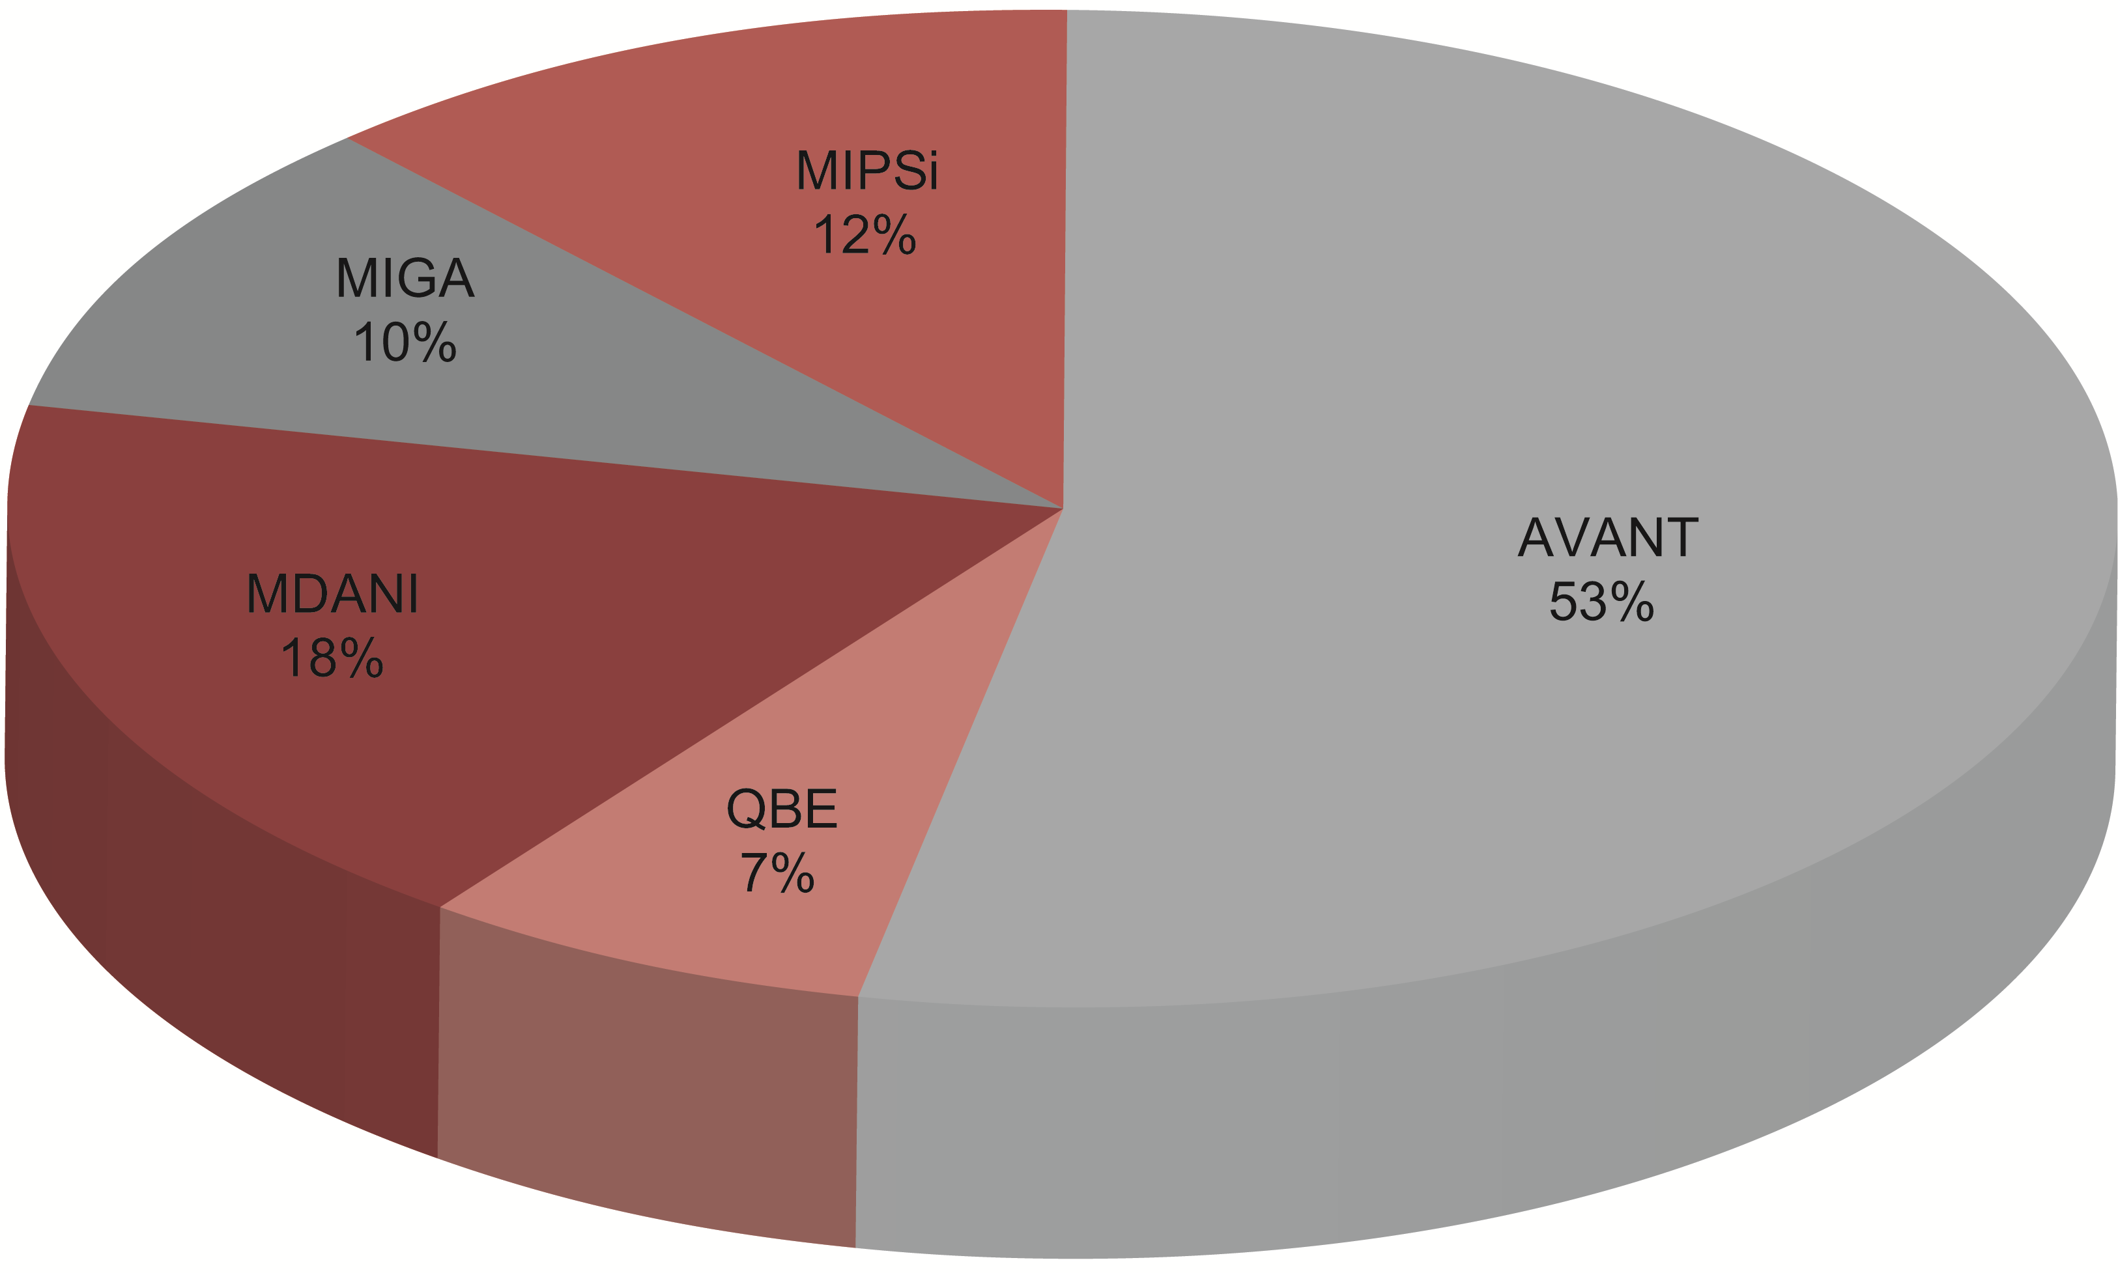
    - Medical negligence claims are initiated by, or on behalf of, patients against doctors. Roughly 2,000 claims of negligence might be expected each year in relation to private medical practice in Australia. However, there can be substantial variation from one year to the next. It is difficult to project the number of medical indemnity claims with any precision. A significant number of claims will be successfully defended.
    - The cost of medical negligence claims is highly variable since the claims relate to bodily injury. The cost of a medical negligence claim to the insurer is made up of damages which are payable to the plaintiff, any of the plaintiff’s legal costs which the insurer is obliged to pay, and the insurer’s own costs of defending and managing the claim. While most claims are finalised for less than $100,000, a small number of claims are large. Perhaps 5 per cent of claims cost more than $500,000. These large claims have a significant impact on the overall cost of medical indemnity insurance. At least 40 per cent of the cost of all medical indemnity claims relates to claims which are larger than $500,000.
    - The medical indemnity claim process can be long. Years can elapse between the date of a negligent medical incident and the date that legal action against the practitioner is initiated. It is not unusual for claims to take a number of years to finalise after they have been initiated. It is common for the whole process to take more than five years for a single claim. The cost of a claim depends significantly on economic and judicial conditions prevailing at the time the claim is finalised (paid), rather than at the time of the medical incident or the time that the claim is made.
    - All of these factors make medical indemnity insurance difficult for an insurer to underwrite. It is hard to forecast claim numbers and claim sizes reliably. Moreover, much of the cost is likely to relate to a small minority of the claims, which adds further uncertainty. As a result, it is difficult to know how much premium to charge and how much money to hold in reserve to pay claims. For these reasons a robust private market in medical indemnity insurance requires professional and disciplined underwriting and management.

Brief history of private medical indemnity insurance in Australia — the lead-up to the Run-Off Cover Scheme

    - Historically, medical indemnity cover was provided to Australian doctors in private practice by medical defence organisations (MDOs). MDOs were not licensed insurers and were therefore not subject to prudential regulation.
    - Medical indemnity cover was originally provided to practitioners on a so-called ‘claims-occurring’ basis. Practitioners were protected against claims that might be made in relation to the medicine that they had practised while members of the MDO. Thus, practitioners who had claims made against them after retirement could seek assistance from their MDO provided that they had been members at the time of the medical incident. Medical indemnity is difficult to underwrite on a ‘claims-occurring’ basis, partly due to the often long delay between the date of medical incident and the time at which a claim is initiated.
    - During the 1990s most MDOs came under financial pressure as a result of increasing levels of claim payments and were forced to make calls on their members for additional funds.
    - At the same time, most MDOs progressively changed the basis of their cover from ‘claims-occurring’ to ‘claims-made’. In simple terms, claims-made cover provided protection for the practitioner against claims that were made during the period of membership. Thus, in order to continue to be covered against claims that might emerge in relation to past medical practice, a doctor had to continue his MDO membership. Professional indemnity insurance is generally provided on a ‘claims-made’ basis.
    - In 2002, Australia’s largest MDO, United Medical Protection, was placed in provisional liquidation. Following this, steps were taken to stabilise the medical indemnity industry.
    - Since 1 July 2003, medical indemnity insurance has been required to be provided to Australian practitioners by insurers licensed under the Insurance Act 1973 and prudentially supervised by APRA.
    - This has ensured a more disciplined approach to underwriting and has reduced the risk of failure of a medical indemnity provider.
    - Consistent with more disciplined underwriting, all medical indemnity insurance is now provided on a ‘claims-made’ basis. Consequently, doctors have to maintain insurance in order to remain covered against claims that might emerge, even if they are no longer practising. This form of insurance cover is known as run-off cover. Put simply, run-off cover provides insurance protection for doctors who have ceased medical practice. The potential delay between a medical incident and a claim highlights the need for doctors to maintain run-off cover after ceasing practice.
    - For some doctors the annual cost of medical indemnity insurance runs into the tens of thousands of dollars. In order to address problems associated with the cost of run-off cover, including the potential threat to the provision of medical services, a scheme was established which requires medical indemnity insurers to provide free run-off cover to certain groups of doctors who have ceased private practice. The Scheme was intended to be largely cost neutral to taxpayers whilst not threatening the viability of the insurance companies. This scheme is known as the Run-Off Cover Scheme.

What is the Run-Off Cover Scheme?

    - The Scheme facilitates the provision of free medical indemnity insurance cover to particular groups of doctors who have ceased private medical practice.
    - The rules for the Scheme appear in the Medical Indemnity (Prudential Supervision and Product Standards) Act 2003 (PSPS Act), the Medical Indemnity (Run-off Cover Support Payment) Act 2004 (MI ROCSPA) and the Medical Indemnity Act 2002. The principal elements of the Scheme are as follows:
- The PSPS Act imposes an obligation on insurers to provide free run-off cover to particular groups of doctors who have ceased private practice.
- The Medical Indemnity Act provides for the Commonwealth to make payments to the insurers to reimburse the costs of eligible run-off claims. These payments are known as ROC indemnity payments.
- The Medical Indemnity Act provides for the Commonwealth to make other payments to insurers to offset the relevant costs of administering the Scheme that are incurred by insurers.
- The Medical Indemnity Act also provides for the insurers to make payments to the Commonwealth to ensure that the Scheme is largely cost-neutral to taxpayers. These payments are levied as a tax on insurers’ premium income. In practice, the cost is met by a loading on practitioners’ medical indemnity insurance premiums. These payments are known as ROC support payments. The MI ROCSPA sets out the rules for calculating ROC support payments.
    - The Scheme provides for ROC support payments to be made by medical indemnity insurers to the Commonwealth and for ROC indemnity payments to be made by the Commonwealth to medical indemnity insurers (MIIs) and MDOs. Ancillary arrangements provide for payments to cover other costs such as administrative costs.
    - Amendments to the primary legislation were passed late in 2006 which simplified the administration of the Scheme. Protocols governing certain administration payments to insurers are now in place.
    - An important financial dynamic of the Scheme is the timing mismatch between the payment of ROC support payments by MIIs and the emergence, payment and reimbursement of medical indemnity claims of eligible doctors who are no longer in private practice. The first ROC support payments were received on 30 June 2005. The Scheme applies to eligible medical indemnity claims that are first notified to the MIIs or MDOs on or after 1 July 2004. As a result of inherent delays in the medical claims process, it is to be expected that the level of ROC support payments will be substantially greater than the level of ROC indemnity payments for a number of years. That is, in a cashflow sense, the Scheme is at a reasonably immature stage. It will probably take until about the middle of the 2020s to reach maturity when income from ROC support payments and expenditure on ROC indemnity payments are of a similar order of size. To preserve the financial integrity of the Scheme, a system of notional accounting is maintained and reported on in section 4 of this report.

Data

Data collection

    - For the purpose of preparing this report, certain data were collected from the MIIs by Medicare Australia during late 2013 including:
- details of practitioners who were identified as having become eligible for membership of the Scheme before 30 June 2013;
- details of claims (including incidents) notified to MIIs and MDOs by 30 June 2013 which might eventually become eligible for reimbursement under the Scheme;
- details of ROC support payments;
- actuarial estimates of that part of the future claims cost of medical incidents projected to be notified during the 2013-14 to 2016-17 financial years which is expected to be reimbursed under the Scheme; and
- actuarial estimates of that part of the future claims cost of medical incidents occurring during 2013-14 which is expected to be reimbursed under the Scheme.
    - This report also utilises other data and information including that which was previously provided to Medicare Australia for the purpose of section 34ZW of the Medical Indemnity Act.

Data verification

    - The results in this report rely on information provided by MIIs. This information is regarded as the most suitable information available for the current purpose.
    - Steps were taken to ensure, as far as practicable, that the information provided was prepared on a basis suitable for the purpose. Despite this, it is not possible to guarantee that the information provided is free from material error. The information was not independently audited. As was the case in previous years, there were some notable disparities in the data provided. This means that figures and estimates provided in this report need to be treated with some caution.
    - Historically, MIIs/MDOs have not maintained data in a form which is directly amenable to ROC analysis. For example, it has not been possible to establish a comprehensive list of doctors who were eligible for the Scheme on 1 July 2004. This is not a criticism of the MIIs. It simply reflects that their business and information systems were not developed with a scheme like the Run-Off Cover Scheme in mind. However, in order to monitor the operation of the Scheme effectively, accurate and timely data is clearly important.
    - Certain information was sought from industry actuaries. Guidance was provided as to the nature of the data, calculations and information required. Discussions with industry actuaries were held to supplement the data provided.
    - A range of assumptions was used by industry actuaries. Although some significant assumptions differ by only a few percentage points between actuaries, substantially different estimates of Scheme costs are produced. This is indicative of the highly uncertain nature of estimates of the costs of the Scheme.
    - It is to be expected that many of the data issues encountered will diminish in time. Until data issues subside, Scheme projections will be subject not only to the considerable inherent uncertainty which surrounds medical indemnity insurance business, but also to additional uncertainty associated with the amount and quality of the available data.
    - In general, the results in this report blend estimates provided by industry actuaries with other actuarial estimates based on data provided by the MIIs and assumptions and models developed within this office.

Eligible practitioners

    - Practitioners performing private practice become eligible for the Scheme by means of permanent retirement at age 65 years or older, cessation of private practice for three years, death, permanent disability or maternity leave. In addition, practitioners who have worked under a subclass 422 (Medical Practitioner) or 457 (Business (Long Stay)) visa under the Migration Regulations 1994 become eligible for the Scheme when they have permanently ceased medical practice in Australia and ceased to reside in Australia.
    - Appendix 2 describes the test of eligibility for the Scheme and the process of issuing and notifying compulsory run-off cover to eligible practitioners. Eligible practitioners are entitled to receive notification of the terms and conditions of compulsory run-off cover from their MII. MIIs are also required to notify Medicare Australia of the details of the compulsory run-off cover provided.
    - There are inherent lags involved in notification of the details of eligible practitioners to Medicare Australia. As a result, it will be possible only to estimate the number of practitioners who have become eligible for the Scheme at any time. For example, there will often be a delay between the time that a practitioner becomes eligible for the Scheme and the time when the insurer becomes aware of this. More generally, it is also very possible that there will be circumstances where an insurer is unsure of the eligibility status of a practitioner indefinitely; for example, where a practitioner has not renewed their insurance for, say, three years. For all of these reasons, the numbers of eligible practitioners reported by insurers need to be treated with caution.
    - The number of practitioners eligible for the Scheme in this report is based on:
- data provided to Medicare Australia by the medical indemnity industry relating to practitioners identified as having become eligible between 1 July 2004 and 30 June 2013; and
- industry estimates of practitioners eligible for the Scheme as at 1 July 2004, provided for the purpose of the 2004-05 report.
    - We have relied largely on the eligibility data provided by the industry. For a small number of records the practitioner’s eligibility date provided was clearly not reasonable, and we have made adjustments accordingly. As has been the case in all previous reviews, data changes from year to year undermine the reliability of the information. Table 1 summarises the data provided by the industry, after adjustments.
Table 1: Run-Off Cover Scheme eligible practitioners
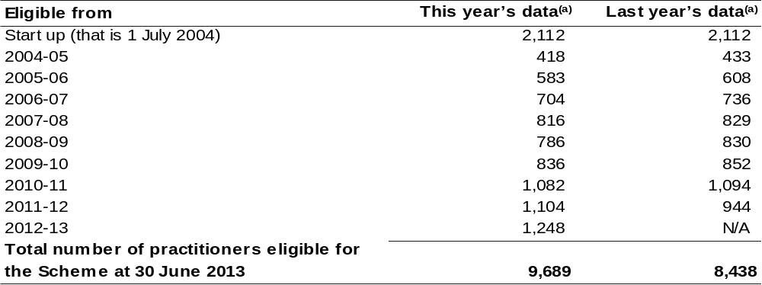
- Note that these numbers have not been reduced in relation to practitioners whose eligibility has subsequently ceased.

    - According to the data provided by the industry, 1,248 practitioners became eligible for cover under the Scheme during 2012-13. In our previous review we estimated that 1,068 practitioners would become eligible for cover during 2012-13.
    - Table 2 below illustrates the breakup of the 2004-05 to 2012-13 new entrants by reason of eligibility, based on the data provided by the MIIs. Also shown are the projected new entrants during 2013-14 from the population of practising at-risk doctors produced by our model.
Table 2: Run-Off Cover Scheme new entrants by reason of eligibility
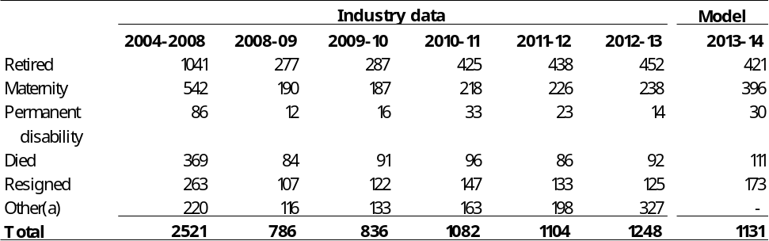
- Overseas trained doctors who had permanently ceased practice under a 422 or 457 visa.

    - We have not projected any new entrants in the ‘other’ category. Historically, practitioners in this category have paid very low premiums. Accordingly, we have assumed that medical negligence claims against them are likely to make an immaterial contribution to the Scheme costs.

Claims eligible for Run-Off Cover indemnity payments

    - MIIs and MDOs are entitled to reimbursement from the Australian Government for the costs of claims which:
- are first notified to the MII or MDO on or after 1 July 2004;
- relate to a practitioner who is eligible under the Scheme at the date of notification; and
- meet the other requirements for ‘payable claims’.
    - As at 30 June 2013, MIIs and MDOs reported 381 medical incidents relating to eligible medical practitioners since the commencement of the Scheme and 179 of those have either led to a payment or have a case estimate attached to them.
    - Table 3 below illustrates the breakup of the reported claims by the year in which the medical practitioner became eligible for ROCS, based on the data provided by the MIIs.
Table 3: Claims eligible for Run-Off Cover indemnity payments by year of eligibility
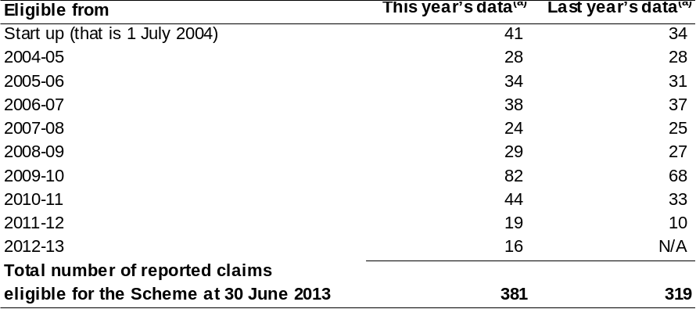
(a) The doctor’s ROCS eligibility date was missing for 26 incidents.

    - The number of medical incidents notified to MIIs and MDOs which could potentially give rise to a future ROC indemnity payment is lower than perhaps might have been expected. At this point we are not assigning full credibility to the data, given the inconsistencies in it and its relatively small volume.

Run-Off Cover indemnity payments

    - ROC indemnity payments are the payments made by the Australian Government to MDOs and MIIs as reimbursement of the costs of eligible claims.
    - The Scheme also provides for payments in respect of compliance costs and indirect claims handling expenses under the ROC Claims and Administration Protocol (section 34ZN of the Medical Indemnity Act).
    - ROC indemnity payments totalling $14 million (including indirect claims handling expenses) had been made up to 30 June 2013, all of them since 1 July 2007. Specifically during 2012-13, $2.96 million in ROC indemnity payments were made.
    - $9.8 million in compliance cost payments have been made to MIIs up to 30 June 2013, while we have estimated that a further $1.2 million relating to periods prior to 30 June 2013 remained unpaid as at 30 June 2013.
    - The Commonwealth’s own administration costs are Budget-funded and so are not considered in this report.

Run-Off Cover support payments

    - ROC support payments are paid to Medicare Australia in the form of an annual lump sum imposed as a tax on each MII from 1 July 2004 under the MI ROCSPA.
    - The amount of ROC support payments is calculated using a method set out in the MI ROCSPA. Appendix 1 describes the calculation in detail. Very briefly, it is based on:
Applicable rate × (premium income less taxes and charges) ÷ (1 + applicable rate).
    - In 2012-13, the applicable rate was 5 per cent for all insurers.
    - Table 4 below summarises the ROC support payments received during the 2012-13 financial year. The total amount increased slightly from that received during the 2011-12 financial year. This was consistent with a slight increase in total medical indemnity premiums paid by practitioners during 2012-13. Some MIIs continue to collect membership fees in addition to medical indemnity premiums. In total, the amount of membership fees collected represents around 10 per cent of the amount of medical indemnity premiums collected across the industry. ROC support payments are not payable on membership fees.
Table 4: Run-Off Cover support payments
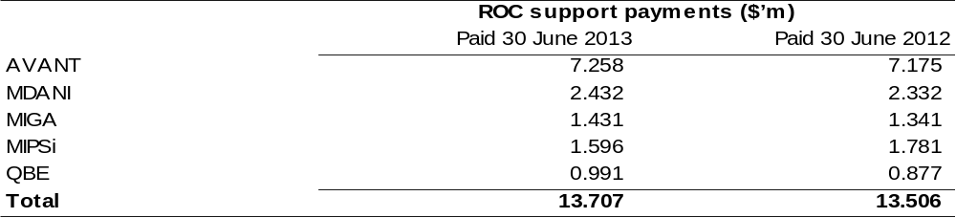

    - In order to provide full transparency for practitioners, MIIs are required to attribute ROC support payments to individual policyholders. Each premium notice specifies the amount that has been included in the policyholder’s invoice to meet the MII’s ROC support payment obligations. All amounts are reported to Medicare Australia, which maintains a record of each practitioner’s total run-off cover credit. Interest is applied to this balance annually at the short term bond rate in accordance with section 34ZS of the Medical Indemnity Act.
    - Part 2, Division 2B, Subdivision E of the Medical Indemnity Act provides for certain payments, should the Scheme ever be wound up without alternative arrangements being put in place. Thus, doctors who were still practising at the time of the windup of the Scheme would be entitled to have an amount not exceeding their total run-off cover credit paid to their nominated medical indemnity provider. Practitioners who were eligible for the Scheme at the time of its wind-up would not be entitled to any refund but would continue to be covered for any future claims that might emerge.
    - Figure 2 below summarises the contribution to ROC support payments by age of practitioner. Note that age and gender were not available for a minority of doctors. The chart is based only on practitioners who paid at least $1,700 in respect of both medical indemnity premium (net of discounts and loadings) and membership fees during 2012-13. We refer to these practitioners as ‘at-risk doctors’. The proportion of ROC support payments is greater than the proportion of practitioners for doctors aged between 40 and 50, and the proportions are similar for doctors aged between 50 and 70. The chart also reflects the low level of premiums for doctors aged in their 20s and 30s and for doctors over age 70 who may tend to wind down their practice hours and possibly perform fewer risky medical procedures (for example, surgery) as they reach more advanced ages.
Figure 2: Contribution to Run-Off Cover support payments by age
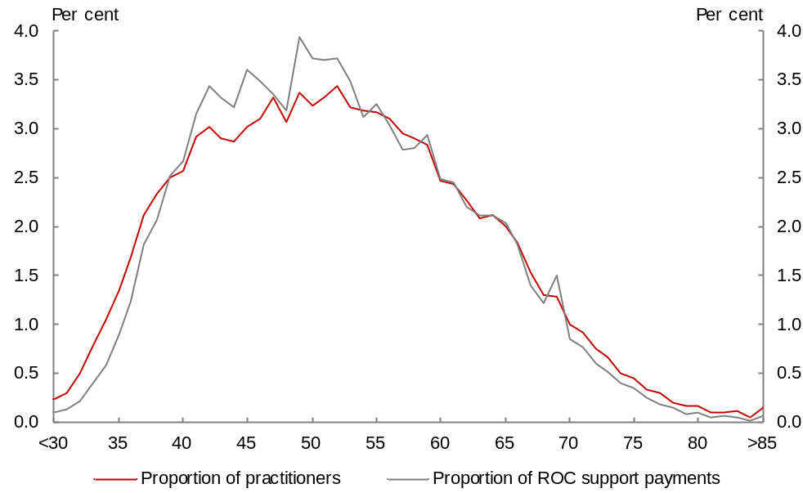

    - Figure 3 below summarises the contribution to ROC support payments by area of specialty. Specialty codes were not available in relation to a small minority of doctors. Similar to Figure 2, this chart only includes ‘at-risk’ doctors.
    - Medical indemnity insurance premiums tend to be risk-based. Thus, practitioners operating in higher risk areas of specialty are likely to incur the highest premiums and, accordingly, the highest ROC support payment liabilities. The largest ROC support payments are for obstetricians, gynaecologists, neurosurgeons, cosmetic/plastic/reconstructive surgeons, orthopaedic surgeons, and general surgeons. General practitioners — non-procedural have the smallest average ROC support payments. Note that most medical practitioners not otherwise classified (including interns, trainees and hospital indemnified doctors) are not shown in this chart as they are not included in the ‘at-risk’ group.
Figure 3: Contribution to Run-Off Cover support payments
by specialisation
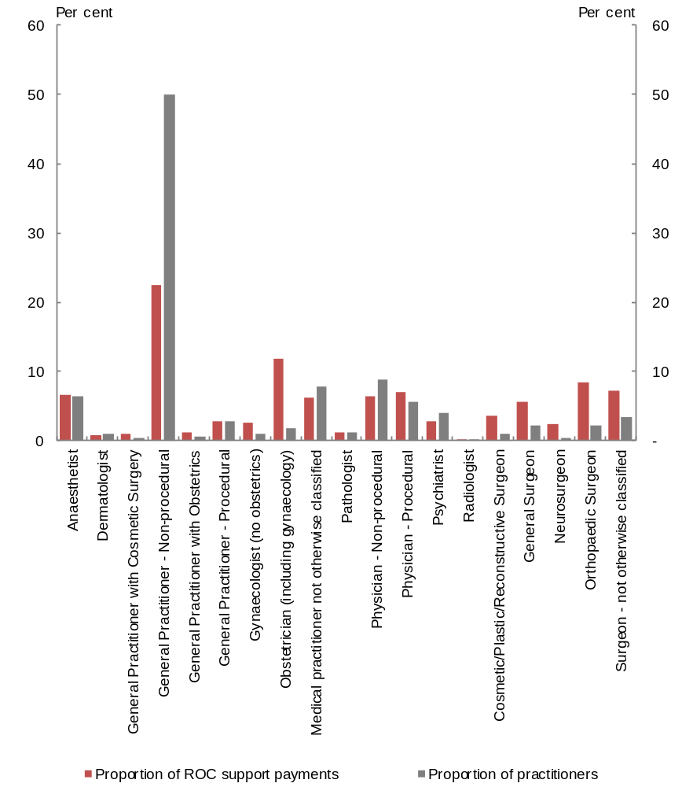

Financial management of the Run-Off Cover Scheme

Future liabilities of the Run-Off Cover Scheme

    - The estimation of the Commonwealth’s liabilities under the Scheme in future years is inherently imprecise. The operation of the Scheme is likely to be characterised by a small number of claims of highly variable size. It is not possible to predict the costs of the Scheme with a high level of confidence. For example, the presence of a single very large claim in any given year could have a substantial effect on the total amount of ROC indemnity payments for that year.
    - The liabilities of the Scheme could be measured in a number of ways. It is normal for insurance-type liabilities to be measured on either a ‘notified’ or an ‘occurrence’ basis. On a notified basis, new liabilities would accrue to the Scheme as new claims were notified. On an occurrence basis, new liabilities would accrue to the Scheme at the time of the occurrence of the medical incidents which were expected to give rise to medical indemnity claims which would attract a ROC indemnity payment.
    - Under the occurrence model, liabilities are recognised more quickly than under the notified model. The occurrence model is more consistent with the notion that the Scheme is ongoing. Accordingly, the occurrence model has been adopted for this report. The liabilities of the Scheme are therefore taken as the present value of future ROC indemnity payments (including associated insurer claims handling expenses) which relate to medical incidents which occurred before the effective date of valuation.

Comment on experience during 2012-13
    - In any actuarial investigation it is appropriate to compare the emerging experience with that previously projected. This analysis informs the assumption setting process for the current investigation.
    - Based on input from industry actuaries and some judgement, the previous report estimated the incurred-but-not-reported (IBNR) Run-Off Cover Scheme liability at 30 June 2012 as $54 million. Implied within that estimate was an expectation that approximately $5.8 million in new notifications would emerge during 2012-13. The most recent actuarial estimates predict about $1.9 million of notifications for 2012-13 and $4.1 million for 2013-14. By way of comparison the previous report noted that, at that time, the most recent actuarial estimates predicted $5.8m in new notifications for 2012-13. The latest estimate of $1.9m is another example of the difficulty in undertaking reliable projections in this context.
    - In relation to Scheme-eligible claims which had been notified at the time of the previous review (30 June 2012), actuarial estimates of the corresponding ROC indemnity payments had a present value then of $11.5 million. In 2012-13, claim payments of about $1.6 million were made by MIIs/MDOs relating to these claims (based on industry data). All else being equal, this would suggest a residual figure at 30 June 2013 of about $10.5 million in today’s dollars. Up to date actuarial estimates put this number at around $6.2 million (excluding 2012-13 notifications). In addition to this, industry actuaries have taken a generally less cautious view of future liabilities. Thus, industry projections of future notifications have generally decreased when compared with the corresponding projections last year.

Changes to assumptions
    - We investigated the recent eligibility experience. During 2012-13 our models, for the first time, projected lower numbers of eligible practitioners than the numbers reported by industry. More generally, there is substantial variability in the reporting of eligible practitioners among the insurers. Furthermore, the data can vary significantly between months of reporting, which undermines the reliability of the data. Accordingly, we have decided to leave our new entrant assumptions unchanged.
    - Claim cost and financial assumptions remain reasonable, based on a high level analysis of the experience to have emerged so far.
    - We have not changed in the way in which we have estimated the IBNR liability. For this review we have again based our IBNR estimate on industry actuarial estimates of future notified cost. We have used our claim reporting assumptions to split the estimates of future notified cost between past and future medical incidents. We have again added a margin to the base IBNR estimate in order to bring it broadly into line with our estimate of new accrual. We have maintained the margin of 20 per cent. We remain satisfied that the approach is reasonable.
    - Our estimates of new accrual are again derived from models developed in this office. In some of the previous reports we included a margin of 25 per cent in the new accrual estimates. Emerging reported experience has continued at a lower level than expected. This year we have not included any margin in the new accrual estimates. The new accrual estimates (net of any margin) are broadly consistent with the other liability estimates.
    - Appendix 4 sets out the main assumptions and describes the methodology that was used to estimate the liabilities. Appendix 5 looks at the effect of the High Cost Claims Scheme (HCCS).

Projected Run-Off Cover indemnity payments
    - This section sets out projections of ROC indemnity payments for the next 10 financial years. For the reasons described above, the projections should be regarded as indicative only. The data issues referred to earlier in this report also contribute to the uncertainty. The underlying assumptions and methodology are described in Appendix 4, with the calculations summarised in Table 16. Table 5 below sets out the projections, which are illustrated in Figure 4. The Scheme is not expected to become mature in a cashflow sense for many years. The payments projected below are in nominal dollars and have not been discounted to current dollar values.
    - The payment figure for 2013-14 is actual payments to the end of June 2014. Generally, ROC indemnity payments are assumed to be made at the same time as the corresponding claim payment. The estimates include indirect costs associated with handling claims, referred to as indirect claims handling expenses (CHE) (see paragraph 4.2.8).
Table 5: Projected Run-Off Cover indemnity payments (including CHE)
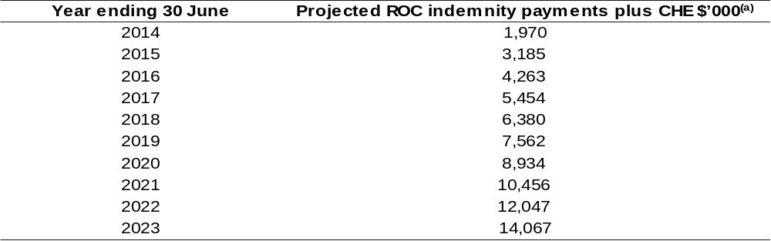
(a) These projected payments do not include administration amounts payable to insurers under the ROC Claims and Administration Protocol.
Figure 4: Projected Run-Off Cover indemnity payments (including CHE)
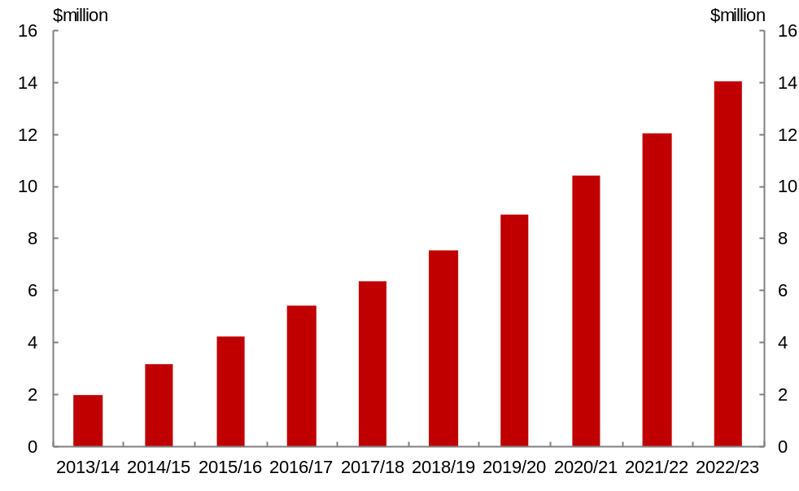

Notional Account

    - The Scheme must be managed over a long time frame. As discussed previously, ROC indemnity payments are likely to be ‘lumpy’ in nature and immature in size for some years. ROC support payments will be received well in advance of ROC indemnity payments. As a result of the payment timing mismatch and the expected volatility in the ROC indemnity payment pattern, it is appropriate to have a system which enables proper tracking of the financial flows over time. Accordingly, a ROC notional account (the Notional Account) is maintained.
    - It is important to appreciate that the Notional Account is not an official Government account. Rather, it is a device established for the sole purpose of facilitating equity between practitioners and other taxpayers.
    - The Notional Account is credited with:
- ROC support payments;
- amounts to offset ROC indemnity payments which relate to doctors who were eligible at the commencement of the scheme; and
- notional interest.
    - Notional interest is credited to the Notional Account to ensure that practitioners derive the proper benefit of the time value of money since ROC support payments are received by Medicare Australia well in advance of any ROC indemnity payments being made by Medicare Australia. Notional interest is applied at the short term bond rate for consistency with section 34ZS of the Medical Indemnity Act which requires interest at the short term bond rate to be applied to the total run-off cover credit balances of individual practitioners.
    - On establishment of the Scheme, the Government announced that it would fund the opening liability that was attributable to practitioners who were already eligible for cover under the Scheme at the time of its commencement. Now that ROC indemnity payments have commenced, effect is given to this commitment by ensuring that the Notional Account is credited with amounts which offset any ROC indemnity payments which relate to doctors who were eligible at the commencement of the Scheme.
    - The Notional Account is charged with:
- ROC indemnity payments; and
- payments made under the ROC Claims and Administration Protocol.
    - The Scheme ‘operates after’ the HCCS. The HCCS meets 50 per cent of the excess above $300,000 of the cost of individual large claims. For example, for a claim which costs $1 million, the HCCS will pick up:
50 per cent × ($1,000,000 — $300,000) = $350,000
    - The Scheme will also pay an amount to a MII or MDO to cover the indirect costs associated with handling claims, referred to as indirect claims handling expenses (CHE). The Scheme pays 5 per cent of the cost of each claim to cover CHE. Table 6 below describes how an eligible $1 million claim would be funded. The total amount paid of $1,050,000 includes claim costs of $1 million and CHE of $50,000.
Table 6: Funding sources for a $1 million claim which is eligible for the Run-Off Cover Scheme
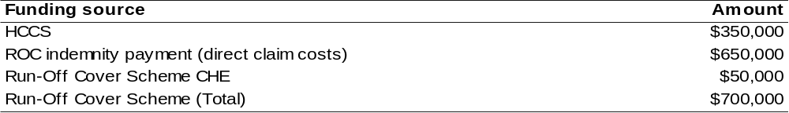

    - Appendix 3 provides more detail on claim amounts eligible under the Scheme.
    - As noted earlier, the Medical Indemnity Act provides for payment of a practitioner’s total run-off cover credit, should the Scheme ever be wound up without alternative arrangements being put in place. Thus, in this event, a large part of the accumulated ROC support payment balance would become a liability of the Scheme. At the same time, since the Scheme liabilities are being measured on an occurrence basis, some of the liabilities of the Scheme would be released, partially offsetting this impact. However, for the purpose of this report, the Scheme has been assumed to be ongoing and the whole amount of the accumulated ROC support payments has been taken to be available to meet relevant ROC indemnity payments.
    - The liability estimates given in this report are central estimates. In broad terms, this means that they are intended to be equally likely to be too high or too low. In particular, it is not intended that the liability estimates contain any margin for risk. Funding considerations for the Scheme are not the same as for private sector insurance arrangements. The objective here is to manage the funding over the long term. Since substantial volatility in the liability estimates is likely from time to time, periods of surplus and periods of deficit in the Notional Account might be expected. However, given the long funding time horizon that is appropriate for the Scheme, a short term deficit in the Notional Account is not a cause for concern. As a result of this, there is no strong reason to maintain a risk margin in the liability estimates.
    - Table 7 below sets out the cashflow statement of the Notional Account for 2012-13.
Table 7: Cashflow statement of the Notional Account 2012-13
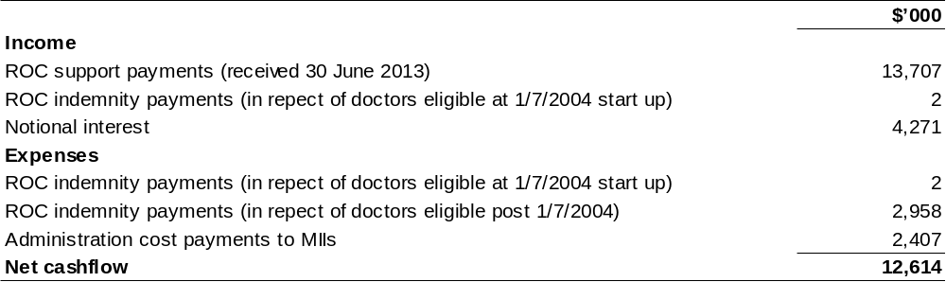

    - Table 8 below sets out the balance sheet of the Notional Account as at 30 June 2013.
Table 8: Balance sheet of the Notional Account as at 30 June 2013
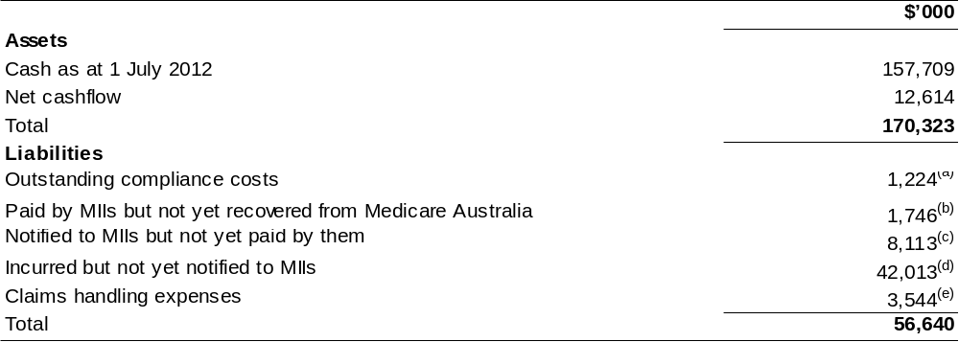
- Estimate only — the amounts of some components of this liability are currently unknown.
- Based on estimates provided in relation to claims/incidents notified to MIIs and MDOs by 30 June 2013.
- Based mainly on estimates provided by industry actuaries.
- Based on estimates provided by industry actuaries and models developed within this office.
- Based on 5 per cent of ‘grossed up’ ROC indemnity payments (to allow for the impact of the HCCS).

    - The Notional Account at 30 June 2013 has disclosed an estimated surplus of about $114 million. Note again that no account has been taken for possible payments to practitioners under Subdivision E of the Medical Indemnity Act, should the Scheme be wound up without alternative arrangements being put in place. Generally, the estimated surplus position should be regarded as highly uncertain.
    - Finally, it is appropriate to provide a benchmark projection of the liabilities of the Scheme. Table 9 below sets out estimates of the liabilities of the Notional Account at the end of each of the next five financial years. The purpose is to illustrate the short-term development of the Scheme. There is very substantial uncertainty in these estimates. The numbers shown have been discounted to the end of the relevant financial year but have not been discounted to give values in today’s terms. The projected liabilities are, in general, about 20-30 per cent lower than the corresponding amounts presented in last year’s report.
Table 9: Projected balance sheet liabilities of the Notional Account
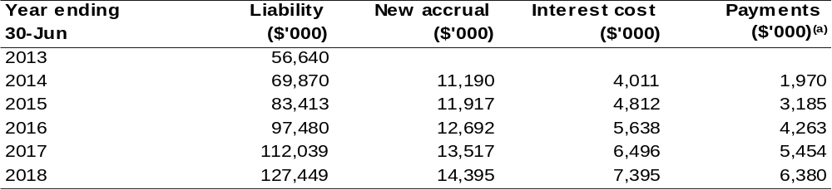
- ROC indemnity payments plus CHE only. Does not include liability in respect of outstanding compliance costs. Refer Appendix 4 for further information.

Actuarial management

    - It is appropriate that the Scheme be subject to ongoing actuarial management.
    - Regular review of the costs and notional assets of the Scheme will allow the ROC support payment rate to be adjusted from time to time, if necessary. Consideration of that rate is beyond the scope of this report. This report has described a framework for the valuation of Scheme liabilities and established the Notional Account. It is intended that the valuation and accounting framework be applied at each future annual review of the Scheme.


Peter Martin FIAA
Australian Government Actuary
14 October 2014

- Appendix 1: Run-Off Cover support payments
  - ROC support payments are paid to Medicare Australia in the form of an annual lump sum imposed as a tax on each MII from 1 July 2004. The lump sum is intended to cover the cost of claims and the MIIs’ administration and implementation costs.
  - The amount of support payments is calculated as a percentage of premium income received from contributing practitioners. The calculation rules are set out in the MI ROCSPA and regulations. The tax imposed on each MII is the applicable percentage of the insurer’s premium income (section 6) for the applicable contribution year ending on 30 June or an alternative date specified in the regulations (section 5).
  - All MIIs except for AMIL were required to remit their first ROC support payments on 30 June 2005. Since AMIL’s policy year was a calendar year, it was not required to remit ROC support payments until 31 December 2005.
  - Under section 7, a MII’s premium income for the purpose is the sum of all of the premiums paid to the insurer for medical indemnity cover provided for medical practitioners, reduced according to the formula:
Premium income equals
Net premium — Net premium × Applicable percentage ÷ (1 + Applicable percentage)
  - Net premium is calculated according to section 7 as follows:
- sum of all premiums paid to the insurer during the operation of the Scheme for medical indemnity cover provided for medical practitioners (including subsidy payments made to the insurer on behalf of medical practitioners to assist with the cost of purchasing medical indemnity cover under the Medical Indemnity Premium Support Scheme, section 43(1) Medical Indemnity Act) (subsection (1));
- minus the amount of GST payable (subsection (2)(a)) and the amount of stamp duty payable (subsection (2)(b)) in relation to the premiums; and
- plus/minus other payments specified in the regulations.
  - For premium payments relating to 2012-13, the applicable percentage is specified in the regulations as 5 per cent for all insurers, and thus the ROC support payment will be calculated as net premium x 5 per cent ÷ 1.05.

- Appendix 2: Eligible practitioners and Run-Off Cover Scheme contracts
Eligible persons
  - Eligible persons are those who fit one or more of the following eligibility categories at the time the claim (or medical incident) is first notified to the MII or MDO (section 34ZB(2) of the Medical Indemnity Act and Medical Indemnity Regulations 2003 regulation 12):
- A doctor 65 years or older who has permanently retired from paid medical practice.
- A doctor who has not engaged in paid medical practice during the preceding three years. (Note: unlike other categories, eligibility does not occur immediately upon ceasing practice).
- A legal representative of a deceased medical practitioner (provided that a claim can be made against the deceased’s estate).
- A doctor who has ceased paid medical practice due to permanent disability.
- A doctor who has ceased paid medical practice because of maternity.
- An overseas trained doctor, who worked under a 422 or 457 visa, has permanently ceased medical practice in Australia and does not reside in Australia.
Provision and notification of compulsory run-off cover
  - The practitioner’s last medical indemnity insurer is required to provide run-off cover to an eligible practitioner under section 26A of the PSPS Act.
  - The compulsory run-off cover must encompass the same nature and range of incidents as the last medical indemnity cover held by the eligible practitioner (subsection 26A(4)(b)).
  - Section 26D compels MIIs to notify eligible practitioners of:
(i) the nature and range of incidents encompassed by the compulsory run-off cover; and
(ii) the terms and conditions on which it is provided.
  - The compulsory run-off cover is taken to be a contract of insurance between the MII and the eligible practitioner for the purposes of the PSPS Act (section 26E).

- Appendix 3: Run-Off Cover Scheme claims
  - The legislation defines claims broadly. Claims need not involve legal proceedings. Claims may include civil claims for negligence, administrative proceedings, disciplinary proceedings (including those performed by a professional body) and inquiries or investigations into conduct (subsection 4(1) of the Medical Indemnity Act).
  - A ROC claim is payable to an MII or MDO under section 34ZC in relation to a claim eligible under subsection 34ZB(1) if:
- it was first notified to the MII or MDO on or after 1 July 2004;
- it relates to a person eligible under subsection 34ZB(2) (see Appendix 2);
- it relates to incident(s) occurring in connection with the person’s practice as a medical practitioner (see paragraph 34ZB(1)(b));
- either the person is indemnified for the claim by an MII in accordance with section 26A of the PSPS Act, or the person is indemnified under incident-occurring based cover provided by an MDO (paragraph 34ZB(1)(e)); and
- the claim would be paid in the ordinary course of the MII’s or MDO’s business.
  - Where these criteria are met, the Commonwealth is liable to pay run-off cover indemnities regardless of whether the MII or MDO has sought private reinsurance (section 34ZF).
  - Applications for ROC indemnity payments must be made to Medicare Australia (section 36 of the Medical Indemnity Act). They are paid by the CEO of Medicare Australia before the end of the month that immediately follows the month in which the MII applies for the indemnity (section 37).
  - The Scheme operates after the HCCS. Thus, part of the cost of eligible large claims is first met by the HCCS with the rest being picked up by the Scheme (subsection 34ZH(2)). Where the total incurred cost of an eligible ROC claim exceeds $300,000, the HCCS meets 50 per cent of the amount by which it exceeds $300,000.

- Appendix 4: Methodology, assumptions and uncertainty
Liabilities as at 30 June 2013
  - Table 10 below summarises the estimated accrued Scheme liabilities as at 30 June 2013. The Scheme liabilities are divided into those attributable to claims notified as at 30 June 2013 and those attributable to IBNR claims as at 30 June 2013. For simplicity, the liability for outstanding compliance costs is not included.
Table 10: Run-Off Cover Scheme liabilities related to medical incidents prior to 30 June 2013 ($’m)
- Including $0.7 million CHE.
- Including $2.9 million CHE.

  - Table 11 below compares the ‘actual’ estimated Scheme liabilities in relation to prior medical incidents as at 30 June 2013 to the ‘expected’ amounts, which are based upon information to 30 June 2012.
Table 11: Actual versus expected liability estimates as at 30 June 2013 ($’m)
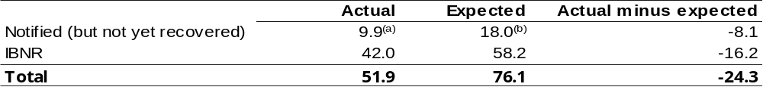
- Including $1.7 million paid by MIIs but not yet recovered from Medicare. Excludes CHE.
- Including $3.0 million paid by MIIs but not yet recovered from Medicare. Excludes CHE.

  - After allowing for the difference between paid but not recovered, the ‘actual’ estimated notified liability is about $6.9 million less than the ‘expected’ liability, based on last year’s review. This relates to downwards revisions in the liability estimates prepared by industry actuaries for incidents which were already notified as at 30 June 2013.
  - For incidents which had not been notified as at 30 June 2013, industry actuaries have revised down their liability estimates. This has led to a lower ‘actual’ estimated IBNR liability than expected (based on last year’s review). This downwards revision is apparent in the estimates provided by most MIIs.
  - After considering the differences between the estimates produced by our internal model and the estimates being prepared by industry actuaries, along with the data issues surrounding the industry’s estimates, we have maintained the margin on IBNR at 20 per cent. As was the case in last report, our model is still producing a higher estimate of accrual than we would expect to be produced by the industry actuaries.
Description of the model used to project the accrual of new Run-Off Cover Scheme liabilities after 30 June 2013
  - The approach involved projecting the expected future ROC indemnity payments for each doctor who was practising as at 30 June 2013. Projection of indemnity payments entailed the projection of:
- incidents which will result in a claim;
- the delay involved in notification of claims;
- the cost of claims after allowing for the HCCS;
- the likelihood of eligibility for the Scheme at the time a claim is notified; and
- the delay involved in the payment of notified claims.
Run-Off Cover claims
Components of claim cost
  - For the purposes of the model, a ROC claim includes any eligible claim notified and finalised at direct cost to the MII. Claim costs include all costs which are directly attributable to the claim. Indirect claims handling expenses (CHE) are dealt with separately.
  - Directly attributable claim costs include damages, plaintiff legal costs to the extent that they are awarded, and defence costs to the extent that they are directly attributable to the claim.
  - The Scheme pays 5 per cent of the direct cost of each eligible claim to cover CHE. Where an eligible claim is partly covered by the HCCS, the allowance for CHE paid under the Scheme is 5 per cent of the total claim cost, including the portion covered by the HCCS.

Assumptions
  - Claim experience has continued to be lighter than expected, based on the assumptions in our previous report. A short period of emerging experience should not necessarily be relied on as a guarantee that underlying assumptions are inappropriate for such a long-tail and uncertain line of insurance as medical indemnity. This is especially true in relation to the Scheme, due, for example, to the following factors:
- ROC claims are very long-tail and model projections are particularly sensitive to assumptions;
- the Scheme is relatively immature;
- systems to facilitate timely and accurate data transfer are still being developed; and
- the Scheme commenced immediately after tort reforms were implemented, with the tort reforms being preceded by a period of abnormally high claim rates ‘claim spike’.
  - We have not altered any of the claim, demographic or financial assumptions in this review.

Claim frequency assumptions
  - Claim frequency and claim size assumptions were made in light of information provided by the actuaries of the MIIs.
  - Practitioners with total medical indemnity payments (including both medical indemnity premiums net of discounts and loadings plus membership fees) of less than $1,700 were excluded from the analysis in order to ensure that only genuine ‘at-risk’ doctors were the focus of the investigation. The excluded group contained interns, trainees and hospital indemnified doctors in some of the data provided by the MIIs. About 76,000 practising doctors have some medical indemnity premium. After excluding those doctors with total medical indemnity payments of less than $1,700 we were left with 40,864 ‘at-risk’ doctors.
  - The overall claim frequency was assumed to be 5 per cent. That is, on average each ‘at-risk’ doctor was assumed to have a 5 per cent chance of being involved in a medical incident in the next year which will result in a future medical indemnity claim. This is unchanged from our previous review. Individual claim frequencies were adjusted based on premium as discussed below.

Adjustment to individual claim frequencies based on premium
  - The likelihood of future notifications of ROC claims was projected according to the assumed ‘riskiness’ of each individual practitioner. The risk of medical indemnity claims posed by each practitioner was determined based on risk categorisation. Practitioners were categorised according to specialisation, age, gender and MII.
  - The average premium for each risk group was used as a proxy for the risk of medical indemnity claims. The claim frequency for each group was multiplied by the ratio of the premium for the group to the premium of the entire cohort of ‘at-risk’ doctors.
  - Although insurance premiums are broadly determined in line with claim risk, the premium of a group is at best an imprecise proxy for risk. For example, market and financial considerations affect premiums charged. However, given the data available, relative premiums have been assumed to be a reasonable means of categorising practitioners according to their risk of medical indemnity claims for the purposes of this model.
  - Insurance premiums tend to diminish for practitioners towards retirement age. This supports the suggestion that doctors tend to wind down their practice hours and possibly perform fewer risky medical procedures (for example, surgery) as they approach retirement. The possible reduction in risk towards retirement is apparent from the pattern of relative premiums for ‘at-risk’ doctors shown in Figure 5 below. In the last report, membership fees were not included in this chart, however the difference is barely noticeable. Note that age and gender were not available for some doctors.
Figure 5: Relative premiums by age for ‘at-risk’ doctors
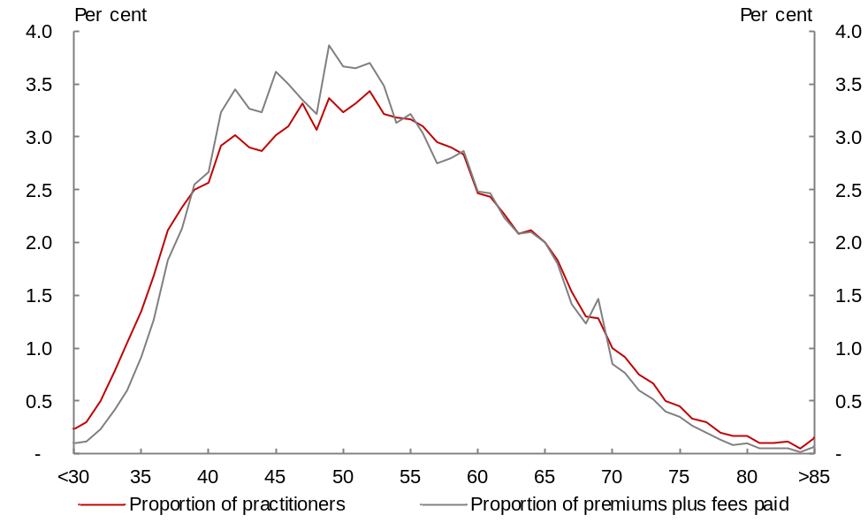
Note: The graph includes all practitioners with total payments (including membership fees) of at least $1,700 from all MIIs.

Adjustment to individual claim frequencies based on assumed wind-down of risky practice
  - The relative premiums of older doctors appear to indicate a reduction in risky practice as doctors approach retirement. Actuaries have also suggested that doctors wind-down their risky practice approaching retirement. However, relative premiums may not capture the full extent of the reduction, since premiums are calculated on a claims-made rather than claims-occurring basis.
  - Again, for this valuation, doctors are assumed to wind-down their risk exposure from age 60, at a rate above that reflected in the premiums. Premium relativities are augmented with a wind-down from age 60 according to the formula 0.933^{(age-59)}, with a multiple of 100 per cent applied until age 60, 50 per cent at age 70 and 25 per cent at age 80.
  - This assumption is very subjective, and is not amenable to objective validation. Nonetheless, it does not appear unreasonable in light of observed claim experience and discussions with actuaries.

Claim size assumptions
  - Claim sizes were assumed to increase with the delay to notification, on the basis that claims which take longer to report tend to be bigger on average for example, cerebral palsy cases.
  - The assumed claim reporting pattern is shown in Table 12 below. Claim sizes presented in the table do not include allowance for inflation or superimposed inflation. Adjustment for inflation and superimposed inflation is discussed below.
  - The claim reporting pattern is based on the reporting patterns provided by the approved actuaries of two of the MIIs.
Table 12: Claim reporting and size pattern
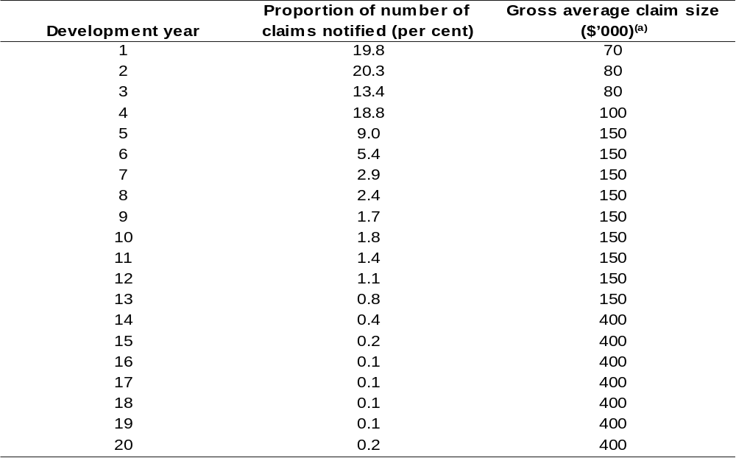
- Gross average claim sizes presented in the table are intended to be in 2013 dollars and do not include allowance for inflation and superimposed inflation.

  - Claims cost net of high cost claim indemnities is calculated assuming that the HCCS threshold will change such that a constant proportion of the gross average claim size will be met by the HCCS. Thus, for simplicity, the HCCS threshold is assumed to increase in line with claims inflation over time. The model effectively assumes that 24 per cent of the total discounted claims cost (in relation to future medical incidents) will be met by the HCCS and 27 per cent of the ROC discounted claims cost will be met by the HCCS.
  - The projected ROC claims cost is very sensitive to the proportion of claims which are assumed to be reported late. The longer the delay between the incident and the claim, the greater the likelihood that a practitioner will be eligible for the Scheme at the time the claim is notified. Thus, the majority of Scheme cost relates to the small proportion of claims which are notified very late. Therefore, a minor change in the assumed proportion of late reported claims can have a significant impact on the estimated ROC claims cost.

Probability of a claim falling under the Run-Off Cover Scheme
  - The model involved projection of the proportion of the total accrual of liabilities which falls under the Scheme.
  - A practitioner can become eligible for the Scheme by reason of:
- retirement at 65 years and older;
- permanent disability;
- death;
- maternity;
- resignation; or
- satisfaction of other eligibility criteria specified in the regulations.
  - The probability of becoming eligible for the Scheme was estimated for each practitioner based on their age as at 30 June 2013 and their sex. Note that practitioners do not become eligible by means of resignation until three years have passed since cessation of practice.
  - The estimated likelihood of practitioners becoming eligible for the Scheme was overlaid on the projected claim notifications to give the projected ROC claim notifications for each practitioner. The expected notified claims cost was multiplied by the likelihood of eligibility in each future year, and summed across all practitioners to arrive at the expected cost of ROC claims notified in that year.
  - In other words, the total ROC claim notifications were calculated as the scalar product of the vector of claim notifications and the vector of probabilities of Scheme eligibility for each practising doctor in each future year.
  - It was assumed that on average practitioners who become eligible for the Scheme do so half-way through the financial year.

Demographic assumptions
  - The probabilities of death and disablement are assumed to be an increasing multiple of the probabilities of death in Australian Life Tables 2005-07 (ALT 2005-07). The probabilities of death are assumed to be 35 per cent of ALT 2005-07 until age 64, 50 per cent from age 65 to 69, and 60 per cent of ALT 2005-07 thereafter. The probabilities of permanent disability are assumed to be 15 per cent of ALT 2005-07 up to age 24, an increasing multiple of ALT 2005-07 from 15 to 30 per cent from age 25 to 64, and 0 from 65 onwards.
  - The assumed probabilities of maternity leave are unchanged and were derived assuming that female practitioners each have an average of 1.5 children between ages 28 and 43 and that they take one year of maternity leave for each child.
  - The probabilities of resignation are assumed to be 0.3 per cent between ages 39 and 53, increasing linearly to 1 per cent at age 60, and increasing linearly to 2 per cent at age 64.
  - The probabilities of retirement are 12 per cent at age 65 and 5 per cent at age 66 increasing linearly to 11.9 per cent at age 89. The probabilities of retirement were assumed to be 100 per cent for ages 90 and above, given the negligible effect on the results.
  - It is instructive to present the probabilities that a practising male doctor will be eligible for the Scheme in future years. The decrement assumptions are summarised in Table 13 in the form of assumed probabilities of being eligible for the Scheme at the end of each of the next 10 financial years for males. The assumed probabilities are very similar to those adopted in last year’s review.
Table 13: Assumed probabilities of eligibility for the Run-Off Cover Scheme over the next 10 financial years for male doctors
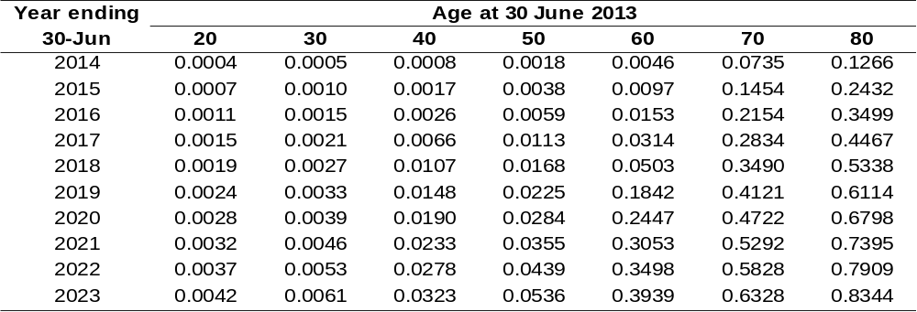

  - Figure 6 below depicts the number of ‘at-risk’ practitioners projected to become eligible for the Scheme by various means during the 2013-14 financial year. Although doctors will become eligible for the Scheme during 2013-14 by way of cessation of practice (having ceased practice during 2010-11), the number below refers to doctors who will actually become eligible during 2016-17.
Figure 6: Projected entries of ‘at-risk’ practitioners to the Run-Off Cover Scheme based on decrement assumptions
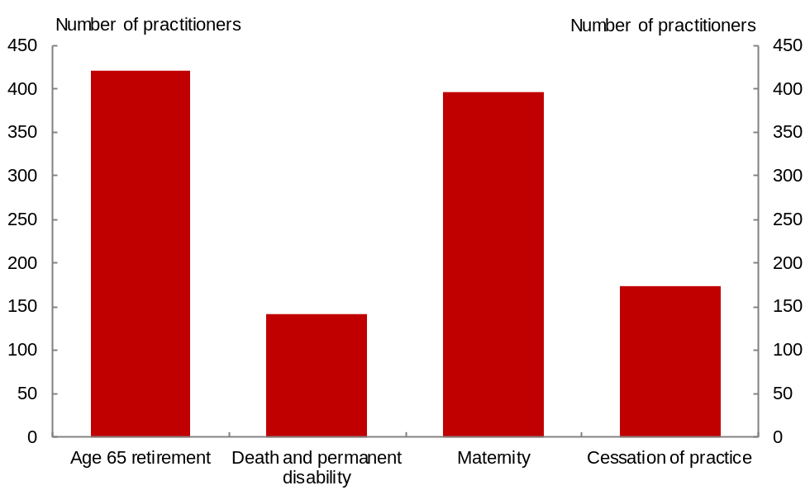

  - As in the previous reports, the numbers of practitioners projected to enter the Scheme was higher than the number provided by the insurers for 2004-05 to 2012-13 financial years (see Table 1).
  - Where the date of birth or gender was not available for a practitioner, these were assigned randomly according to the age and gender distribution of ‘at-risk’ doctors.

Payment patterns, inflation and discounting
  - ROC indemnity payments in relation to medical incidents occurring after 30 June 2013 were projected assuming the payment pattern in Table 14 below.
  - This payment pattern has not changed from that adopted in last year’s report.
Table 14: Payment pattern assumed
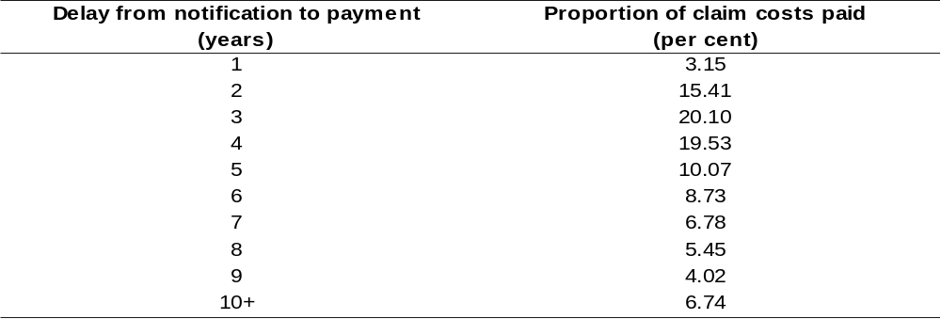

Economic assumptions
  - Medical indemnity claim costs tend to increase at a faster rate than general inflation. Claim payments were projected to increase in line with wage inflation plus superimposed claim cost inflation.
- Wage inflation was assumed to be 4 per cent per annum. This is not inconsistent with general expectations of wage growth.
- Superimposed inflation was assumed to be 2.5 per cent per annum. Superimposed inflation refers to the tendency for medical indemnity claim amounts to increase at rates faster than general inflation. Bursts of superimposed inflation have been observed in the past. Despite this, superimposed inflation is typically allowed for with a constant assumption. For this exercise, an allowance of between 2 per cent and 5 per cent per annum might be reasonable. We have adopted an assumption towards the lower end of this range, having regard to the potential impact of the various tort reforms that have taken place over the last few years.
  - Claim payments were discounted at a rate of 6 per cent per annum. This is the same rate as was assumed last year. The chosen rate provides consistency with the rate adopted in a number of similar contexts and therefore is suitable from a whole of government perspective.
Data summarising the cohort of ‘at-risk’ doctors
  - Table 15 summarises the age distribution of the cohort of ‘at-risk’ practitioners, with the total premium representing a proxy for risk of medical indemnity claims for each age group. Note that age and gender were not available for some doctors.
Table 15: Cohort of ‘at-risk’ doctors
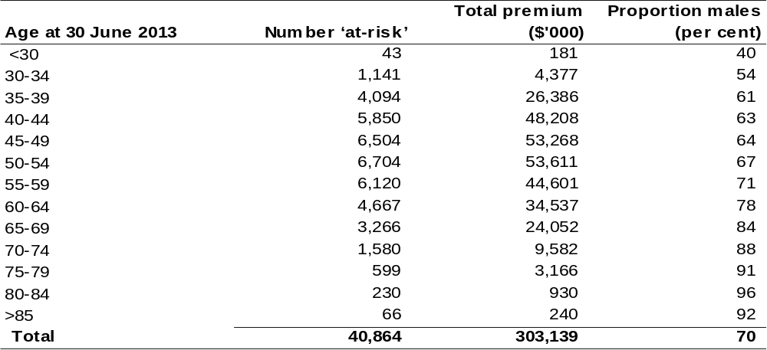
Note: Numbers may not add due to rounding. Total premium includes membership fees. If membership fees are excluded, total premium is approximately $296 million.
Projection of future Run-Off Cover Scheme costs
  - Table 16 below summarises the next 10 years’ ROC indemnity payments which were aggregated to derive the projected Scheme costs in future years. The payment projected for 2013-14 is actual payments made by Medicare Australia to the end of June 2014.
Table 16: Calculation of projected Run-Off Cover indemnity payments
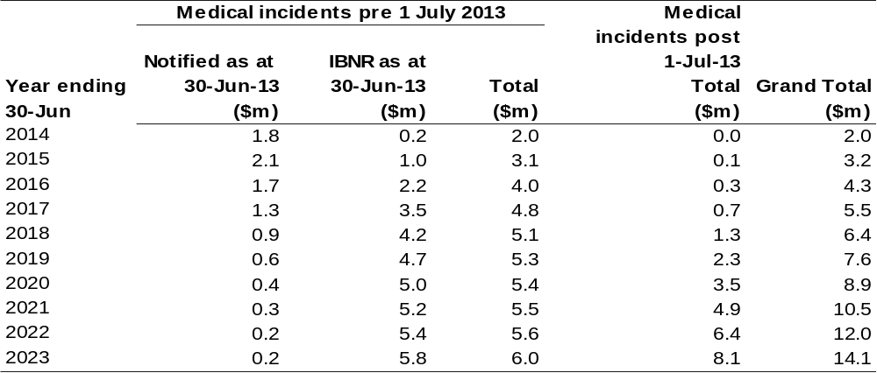
Note: The costs of notified and IBNR claims do not always sum to the total cost of medical incidents pre 1 July 2013 due to rounding.
Uncertainty in relation to liability projections
  - The projected ROC indemnity payments summarised in Table 16 are subject to uncertainty which relates to:
- data in relation to the claiming behaviour of eligible practitioners;
- substantial random variation associated with medical incidents and the notification of claims from year to year;
- calibration of the model claim size and claim frequency assumptions to the underlying claim process (medical indemnity liabilities are characterised by few claims associated with large random variation such that a wide range of results can be obtained with equal statistical validity);
- the extent to which doctors approaching retirement might cut down on their practice hours and possibly engage in less ‘risky’ practice (for example, less surgery);
- sensitivity of the model to the proportion of late-reported claims;
- sensitivity of the model to the decrement assumptions;
- the possibility that not all Scheme eligible claims have been identified and that recoveries will be more diligently pursued later in the claim process; and
- recent tort reforms in a number of jurisdictions with the possible effect of ‘bringing forward’ claims and distorting recent claim experience.
  - The information provided by the actuaries of the MIIs and MDOs relied on broadly similar valuation models. The range of assumptions adopted by industry actuaries reflects the substantial uncertainty involved in estimating liabilities of the Scheme.
  - It must be emphasised that different results can be obtained from different yet equally plausible models and assumptions. Again, this is a common issue with liabilities of this nature.
  - An estimate of the projected accrual of ROC liabilities during the 2013-14 financial year was provided by each of the actuaries of the MIIs; these summed to $8.2 million (including CHE). This can be compared to the estimate produced by our model (including CHE) of $11.2 million.
- Appendix 5: High cost claims
The High Cost Claims Scheme
  - The HCCS is part of the broader package of Australian Government measures announced on 23 October 2002 that were designed to address problems with the medical indemnity insurance industry.
  - The HCCS is governed by Division 2 of Part 2 of the Medical Indemnity Act 2002. Under the HCCS, MIIs and MDOs are reimbursed for part of the costs of large claims notified to them on or after 1 January 2003.
  - The HCCS meets 50 per cent of the excess above the threshold (currently $300,000) of the cost of individual large claims, before the operation of the Scheme.
  - The HCCS threshold and the percentage used to calculate the amount of indemnity can be changed by way of regulation. The HCCS threshold has been changed by way of regulation as follows:
- $2 million for claims notified between 1 January 2003 and 21 October 2003;
- $0.5 million for claims notified between 22 October 2003 and 31 December 2003; and
- $0.3 million for claims notified 1 January 2004 and later.
  - For example, for a claim which costs $1 million notified on 1 April 2012, the HCCS will pick up:
50 per cent × ($1,000,000 — $300,000) = $350,000
Data collection
  - Medicare Australia collects data in relation to the HCCS, in addition to the Scheme data described in section 3.
  - Data collected in relation to the HCCS include:
- details of claims/incidents notified to MIIs and MDOs by 30 June 2013 which might lead to recoveries under the HCCS;
- actuarial estimates of that part of the cost of claims relating to incidents which occurred before 30 June 2013 and are expected to be to be recoverable under the HCCS; and
- an estimate of that part of the future claims cost of medical incidents notified during the 2013-14 to 2016-17 financial years which is expected to be recoverable under the HCCS.
Relevance of High Cost Claims Scheme data to the Run-Off Cover Scheme
  - A small proportion of medical indemnity claims are larger than $300,000. These high-cost claims have a noticeable influence on the total cost of medical indemnity each year.
  - Claims which take longer to report tend to be bigger on average. In addition, the longer the delay involved in notifying a claim, the more likely the claim will be notified at a time when the practitioner is eligible for the Scheme.
  - Thus, the small proportion of large claims made by retired practitioners will have a marked impact on the total cost of the Scheme.
Analysis of large claims
  - HCCS data collected by Medicare Australia provide some insight into the likely profile of large medical indemnity claims.
  - According to the data collected, as at 30 June 2013, 958 claims/incidents had been notified to MIIs and MDOs which were expected to be covered by the HCCS.
  - The cost estimates available for HCCS claims/incidents represent total case estimates, including amounts already paid as at 30 June 2013. This figure is around $813 million. Of this, around $458 million had already been paid by insurers as at 30 June 2013, and around $355 million remained outstanding.
  - The HCCS data provides a reasonable but imprecise measure of the likely profile of large medical indemnity claims.
  - The distribution of estimated costs of HCCS-eligible claims notified between 1 January 2004 and 30 June 2013 is shown in Table 17. The distribution is presented in terms of the proportion of total estimated claim cost attributable to each claim size band. For example, about one fifth of the total estimated cost of HCCS-eligible claims was attributable to claims expected to cost between $0.3 million and $0.5 million.
Table 17: Distribution of High Cost Claims Scheme-eligible claims


  - The HCCS data illustrates the pattern of delay between a relevant negligent medical incident and the date that a large claim/incident is notified to the MII or MDO. The claim reporting pattern (based on claim numbers) observed in relation to HCCS claims is compared in Figure 7 to the general medical indemnity claim reporting pattern assumed for the purpose of undertaking the Scheme cost analysis. Note that eligible claims are included which were notified between 1 January 2004 and 30 June 2013, with an applicable threshold of $0.3 million.
Figure 7: High Cost Claims Scheme claim reporting pattern
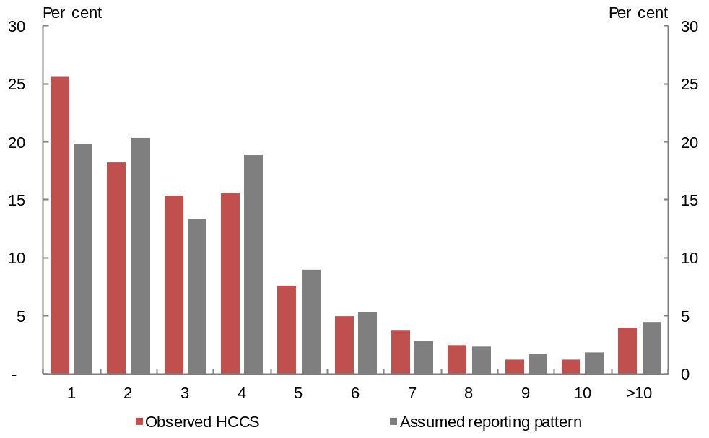

Medical indemnity insurance can also cover other costs such as those associated with appearing at coronial inquiries.
On the other hand, many employed practitioners such as doctors practising solely in a public hospital will be indemnified by their employer against negligence.
QBE’s medical indemnity business was acquired by MIGA in March 2013.
A database of ROC support payments is maintained by Medicare Australia.
At-risk practitioners are defined in paragraph A.4.13.
Refer paragraph A.2.1.
Refer paragraph A.3.2.
Estimate of likely cost to the insurer.
Since the Scheme commenced on 1 July 2004, the relevant HCCS threshold is currently $300,000.

